2. Prioritising
- Make choices about what to do.
In any one-day or week, you have only so much time and energy.
- Think about what needs to be done and what you enjoy doing.
It is important to get a good balance between chores and enjoyable activities.
- List the activities you do in a week, mark those which are most important and ones that can be done less often.
3. Planning
- Plan what you are going to do, rather than simply what you feel like doing at the time.
- Decide when and how you are going to do the activities you have chosen to do (e.g. sitting down). Make sure that the tasks and activities that are most demanding are spread out and not all done in one go.
- Ensure adequate rest periods between activities.
- Can you break the task down into smaller chunks?
- Ask for help if it is available to you, it is important that you focus on your recovery at this point.
Asking for help is a sign of strength as you acknowledge your current situation.

Remember this is a journey and things do not always go to plan!
You will have good days and bad days but stay determined and these techniques will pay off!
Once you are able to tolerate general day-to-day activities, add in gentle strengthening and aerobic exercises.

Recovery after Critical Illness Team
Email: RaCI@royalberkshire.nhs.uk
Tel: 0118 322 7248

Designed with patient feedback.

To find out more about our Trust visit www.royalberkshire.nhs.uk
Please ask if you need this information in another language or format.
Philippe Nicol - RACI physiotherapist, September 2021
Next review due: September 2023
ICU: Fatigue management

Information for patients

Patients who have been in the Intensive Care Unit may find that they struggle to perform tasks without experiencing symptoms of fatigue (extreme tiredness). This leads to becoming increasingly inactive or catching up on jobs on a “good day”, resulting in a flare-up of their symptoms and the need to recover.
This leaflet outlines some strategies to help you manage fatigue and aid your recovery.
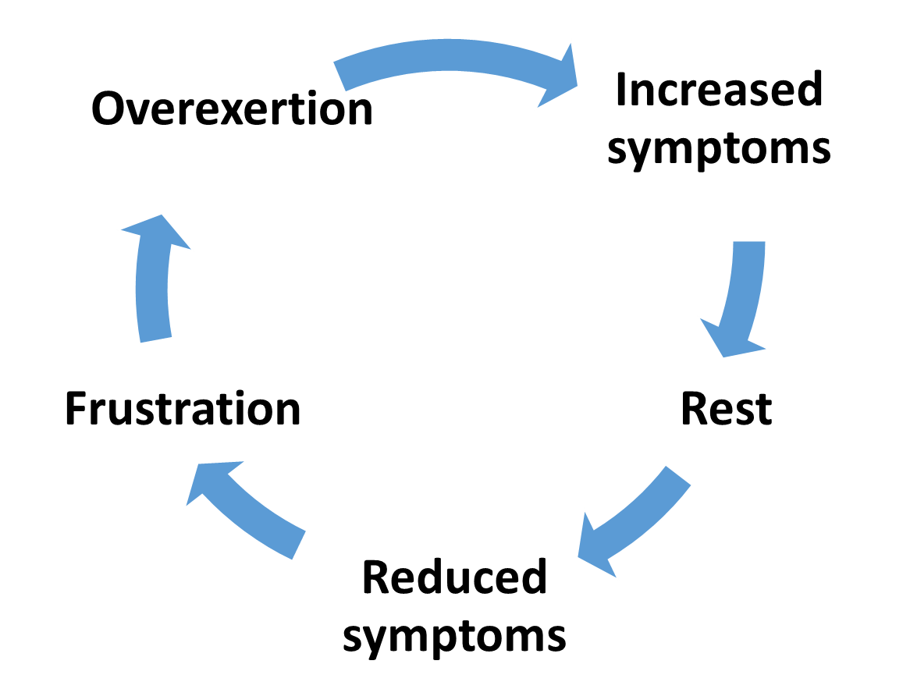
The cycle of over-activity and underactivity is shown in this diagram.
Before using the techniques in this booklet, choose a way of measuring your activity levels so you can monitor progress.

You may prefer to measure distance or repetitions, e.g. 1km walk, climbing the stairs x 3, or use time as a measurement, e.g. 5 minute walk, 10 minutes of dusting.

Visualising your fatigue
There are many ways to think of fatigue. Some people use the ‘piggy bank’ analogy where activities add or take away energy (money). You may find that some of the ‘energy out’ activities that were relaxing previously, now result in fatigue.

It is important that you keep your balance positive!

Energy out
Telephone calls
Watching TV
Housework / exercise
Gardening
Reading
Visiting busy environments

Energy in
Diet / nutrition
Good sleep patterns
Reducing stress
Regular breaks



Keep a diary
A good way of identifying fatiguing activities is by using a diary where you document how you feel after performing an activity for a specified time/distance.
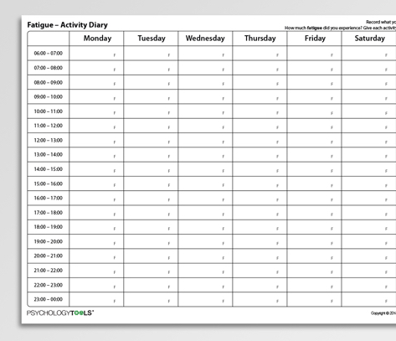
You can then use this to monitor your progress.

Pacing techniques – Using the 3 P’s
1. Pacing
- Pacing means spending just enough time on an activity to get the most you can out of it. This is without pushing yourself so far that you end up worsening your symptoms. Stop BEFORE you get tired.
- There is no set amount of time for doing an activity. Knowing when to stop each activity is a matter of trial and error. Use a fatigue diary to identify patterns.

